**Bitbucket with Jenkins:**

**Promoted build plugins: given by Mohit:**

https://wiki.jenkins.io/display/JENKINS/Promoted+Builds+Plugin

**Jenkins promoted builds:**

https://www.cloudbees.com/blog/another-look-jenkins-promoted-builds-plugin

<https://blogs.perficient.com/2017/06/14/jenkins-delivery-pipeline-and-build-promotion-2/>

**Does Jenkins create upstream and downstream automatically?**

<https://stackoverflow.com/questions/17803165/does-jenkins-create-upstream-downstream-automatically>

**Fingerprints:**

<https://wiki.jenkins.io/display/JENKINS/Fingerprint>

<https://github.com/stephanmg/travis-dependent-builds>

**Jenkins fingerprint:**

<http://rodrigozrusso.com/2016/11/09/jenkins-fingerprinting.html>

**Fingerprint certified:**

https://www.greenreedtech.com/jenkins-certified-engineer-fingerprints/

**Artifacts md5:**

https://stackoverflow.com/questions/33773511/jenkins-get-build-details-by-artifacts-md5

**How to check finger print directly:**

https://stackoverflow.com/questions/45555108/jenkins-fingerprints-checksum-for-files-with-same-content

<https://www.lifewire.com/validate-md5-checksum-file-4037391>

**Script :**

<https://stackoverflow.com/questions/23384196/how-to-run-git-hook-script-on-windows-using-repository-through-filesystem>

**How can I execute shell script in Jenkins file?**

<https://stackoverflow.com/questions/21276351/how-can-i-execute-shell-script-in-jenkinsfile>

<https://support.cloudbees.com/hc/en-us/articles/219046328-Promoted-builds-do-not-receive-parameterized-builds>

**ACCORDING TO PIPELINE:**

https://stackoverflow.com/questions/24382985/jenkins-promoted-builds-in-pipeline-configuring-parameters-in-promotion-actio

**How to configure email notification in Jenkins:**

<https://www.360logica.com/blog/email-notification-in-jenkins/>

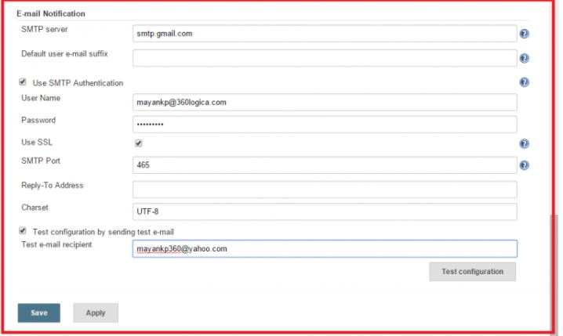

<project xmlns="http://maven.apache.org/POM/4.0.0" xmlns:xsi="http://www.w3.org/2001/XMLSchema-instance"

         xsi:schemaLocation="http://maven.apache.org/POM/4.0.0 http://maven.apache.org/maven-v4_0_0.xsd">

  <modelVersion>4.0.0</modelVersion>

  <groupId>com.example.maven-samples</groupId>

  <artifactId>parent</artifactId>

  <packaging>pom</packaging>

  <version>1.0-SNAPSHOT</version>

  <name>Parent</name>

  <description>Just a pom that makes it easy to build both projects at the same time.</description>

  <modules>

    <module>multi-module</module>

    <module>single-module</module>

  </modules>

  <prerequisites>

    <maven>3.0.3</maven>

  </prerequisites>

<fingerprint>

  <timestamp>2019-01-08T16:34:45+05:30</timestamp>

  <original>

    <name>upstream</name>

    <number>7</number>

  </original>

  <md5sum>da0fb0e7315709cc388ad05253b9</md5sum>

  <fileName>single-module-project.jar</fileName>

  <usages>

    <entry>

      <string>upstream</string>

      <ranges>7</ranges>

    </entry>

  </usages>

  <facets/>

</fingerprint>

</project>

https://python-jenkins.readthedocs.io/en/latest/examples.html#example-3-working-with-jenkins-jobs

[‎1/‎14/‎2019 3:59 PM]  Sana, Tasmiya:

https://python-jenkins.readthedocs.io/en/latest/

# How to trigger a Jenkins build process by a GitHub push

<https://learning-continuous-deployment.github.io/jenkins/github/2015/04/17/github-jenkins/>

# Jenkins Integration with Bitbucket/Github Webhook

<https://medium.com/@mohan08p/jenkins-integration-with-bitbucket-github-webhook-25a191507cab>

# [How to trigger automatic start of job in Jenkins on a custom(non master) branch?](https://stackoverflow.com/questions/48894568/how-to-trigger-automatic-start-of-job-in-jenkins-on-a-customnon-master-branch)

<https://stackoverflow.com/questions/48894568/how-to-trigger-automatic-start-of-job-in-jenkins-on-a-customnon-master-branch?rq=1>

 https://mohamicorp.atlassian.net/wiki/spaces/DOC/pages/121274372/Configuring+Webhook+To+Jenkins+for+Bitbucket

# Configuring Webhook To Jenkins for Bitbucket (Bitbucket Branch Source Plugin)

<https://mohamicorp.atlassian.net/wiki/spaces/DOC/pages/381419546/Configuring+Webhook+To+Jenkins+for+Bitbucket+Bitbucket+Branch+Source+Plugin>

<project xmlns="http://maven.apache.org/POM/4.0.0" xmlns:xsi="http://www.w3.org/2001/XMLSchema-instance"

xsi:schemaLocation="http://maven.apache.org/POM/4.0.0 http://maven.apache.org/maven-v4_0_0.xsd">

<modelVersion>4.0.0</modelVersion>

<groupId>com.example.maven-samples</groupId>

<artifactId>parent</artifactId>

<packaging>pom</packaging>

<version>1.0-SNAPSHOT</version>

<name>Parent</name>

<description>Just a pom that makes it easy to build both projects at the same time.</description>

<modules>

<module>multi-module</module>

<module>single-module</module>

</modules>

<prerequisites>

<maven>3.0.3</maven>

</prerequisites>

<fingerprint>

<timestamp>2019-01-10T11:43:01+05:30</timestamp>

<original>

<name>parent</name>

<number>9</number>

</original>

<md5sum>a8db8bec0bac05208bddb053073d</md5sum>

<fileName>single-module-project.jar</fileName>

<usages>

<entry>

<string>parent</string>

<ranges>9</ranges>

</entry>

</usages>

<facets/>

</fingerprint>

</project>

https://wiki.jenkins.io/display/JENKINS/Authenticating+scripted+clients

**How to configure Email notification in Jenkins:**

<https://www.360logica.com/blog/email-notification-in-jenkins/>

**Problem in Email Configureation:**

<https://stackoverflow.com/questions/25718290/jenkins-smtp-email-configuration-fails-verification>

<https://stackoverflow.com/questions/32450382/535-5-7-8-username-and-password-not-accepted-error>

# How can I authenticate with bitbucket via REST api in python

<https://community.atlassian.com/t5/Answers-Developer-Questions/How-can-I-authenticate-with-bitbucket-via-REST-api-in-python/qaq-p/492887>

# Triggering Jenkins Jobs using REST calls

<https://medium.com/@prakashvadrevu/triggering-jenkins-jobs-using-rest-calls-a632d45488bd>

**Action Item2:**

In bitbucket branch we have a Jenkins File, then trigger a plugin (Create a job in Jenkins of that Jenkins file)

**Solution:**

**Upstream and downstream:**

https://scmquest.com/pass-jenkins-upstream-job-parameter-to-downstream-job/